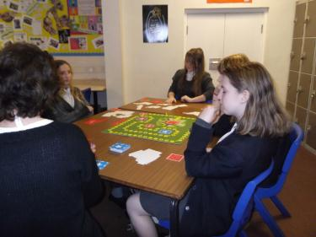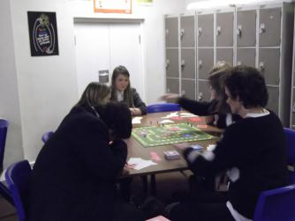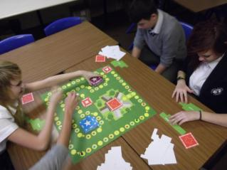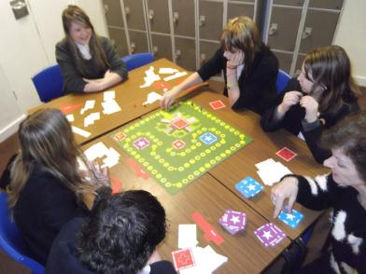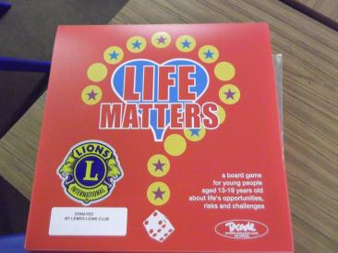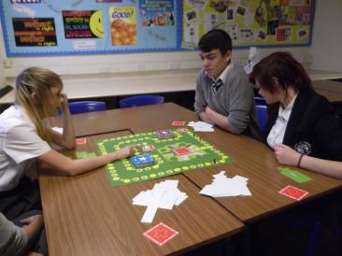

It just so happened that I had a lesson with a very small group this morning and the two games were great. I would love to expand the collection of these games at some point, as the students loved it and it prompted really good discussion around sensible choices particularly to do with sex and drugs. They were able to learn new facts and more importantly consolidate the learning that we do at Priory School, Lewes.

Thank you so much for your support again.

*Helen Fines*

*Life Skills Department*

*Priory School, Lewes*